Basic Beginning Sign Language

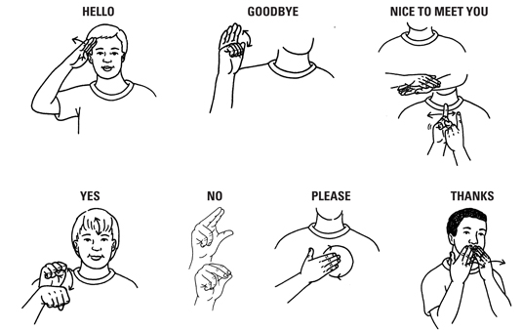

Courtesy of Confessions of a Deafblind Mother www.deafblindconfessions.com

